Homework 04

The last homework involves many graphs; submit it as an electronic Word file that is readable for Office 2003. Try to make your graph as professional as possible.

1. The file “DailyFord.csv” represents the daily stock information of Ford Motor Company from January 2, 2003 to present. Assuming that January 2, 2003 is Monday, graph each of the following:
<a> Graph the comparison between the daily opening price and closing price.

daily.ford<-read.csv("F:/Documents/DailyFord.csv",dec=".",sep=",",header=T)
attach(daily.ford)
y<-ts(Open,start=1,freq=1)
x<-ts(Close,start=1,freq=1)
plot(y,main="Daily Opening and Closing Price",xlab="Day",ylab="Volume",ylim=c(1,30),col=1)
par(new=T)
plot(x,main="",xlab="",ylab="",ylim=c(1,30),col=2)
legend(1000,25,c("x01","x02"),fill=1:2,cex=.8)

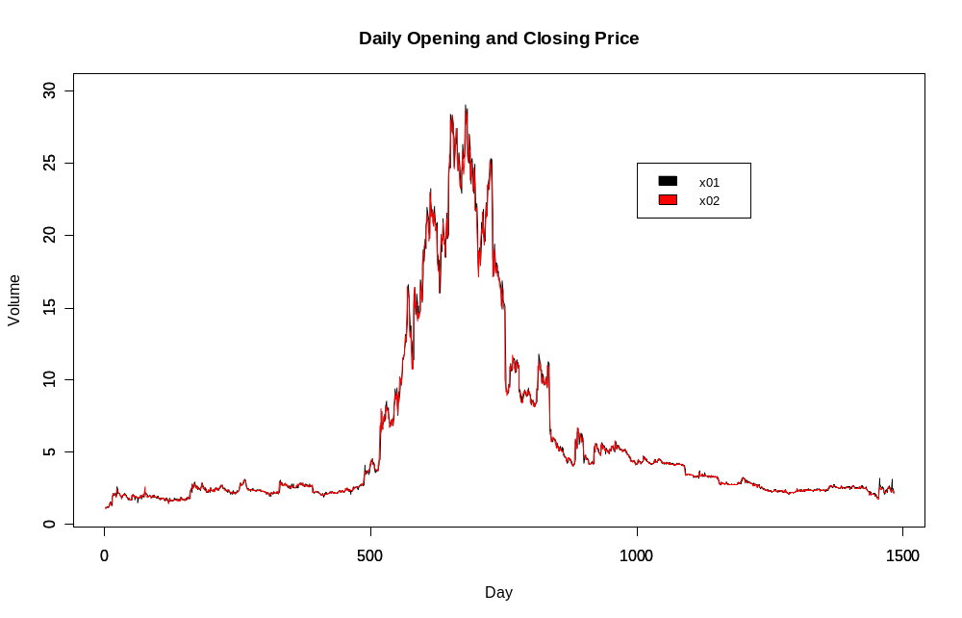

<b> Graph the comparison between the daily high and low.
a<-ts(High,start=1,freq=1)
b<-ts(Low,start=1,freq=1)
plot(a,main="Daily High and Low Price",xlab="Day",ylab="Volume",ylim=c(1,30),col=3)
par(new=T)
plot(b,main="",xlab="",ylab="",ylim=c(1,30),col=4)
legend(1000,25,c("x03","x04"),fill=3:4,cex=.8)

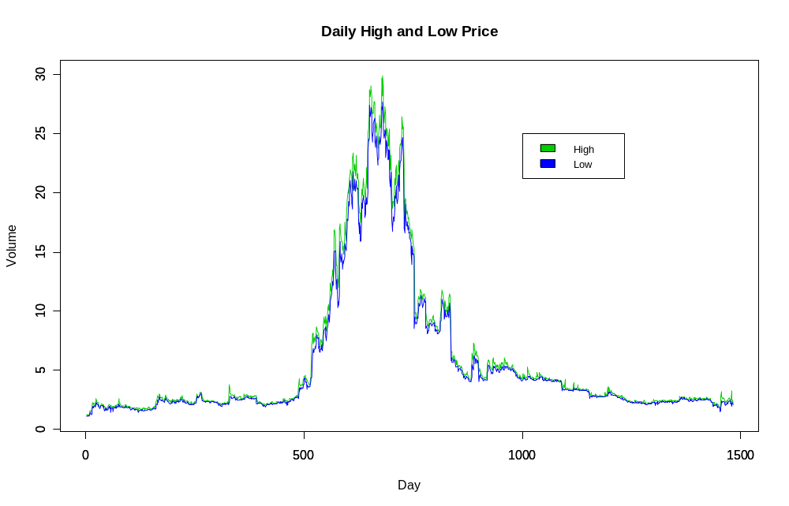

<c> Compare the daily closing prices for Mondays, Tuesdays, …, Fridays.
first.seq<-seq(1,length(Close),by=5)
second.seq<-seq(2,length(Close),by=5)
third.seq<-seq(3,length(Close),by=5)
fourth.seq<-seq(4,length(Close),by=5)
fifth.seq<-seq(5,length(Close),by=5)

mon<-seq(0,0,length=length(first.seq))
tue<-seq(0,0,length=length(second.seq))
wed<-seq(0,0,length=length(third.seq))
thur<-seq(0,0,length=length(fourth.seq))
fri<-seq(0,0,length=length(fifth.seq))

one<-0
two<-0
three<-0
four<-0
five<-0

for(i in first.seq){
one<-one+1
mon[one]<-Close[i]
}

for(i in second.seq){
two<-two+1
tue[two]<-Close[i]
}

for(i in third.seq){
three<-three+1
wed[three]<-Close[i]
}

for(i in fourth.seq){
four<-four+1
thur[four]<-Close[i]
}

for(i in fifth.seq){
five<-five+1
fri[five]<-Close[i]
}
monday<-ts(mon,start=1,freq=1)
plot(monday,main="Comparison of Closing Values by Day",xlab="Day",ylab="Volume",ylim=c(1,30),col=1)
par(new=T)
tuesday<-ts(tue,start=1,freq=1)
plot(tuesday,main="",xlab="",ylab="",ylim=c(1,30),col=2)
par(new=T)
wednesday<-ts(wed,start=1,freq=1)
plot(wednesday,main="",xlab="",ylab="",ylim=c(1,30),col=3)
par(new=T)
thursday<-ts(thur,start=1,freq=1)
plot(thursday,main="",xlab="",ylab="",ylim=c(1,30),col=4)
par(new=T)
friday<-ts(fri,start=1,freq=1)
plot(friday,main="",xlab="",ylab="",ylim=c(1,30),col=5)
legend(1000,25,c("Monday","Tuesday","Wednesday","Thursday","Friday"),fill=1:5,cex=.8)

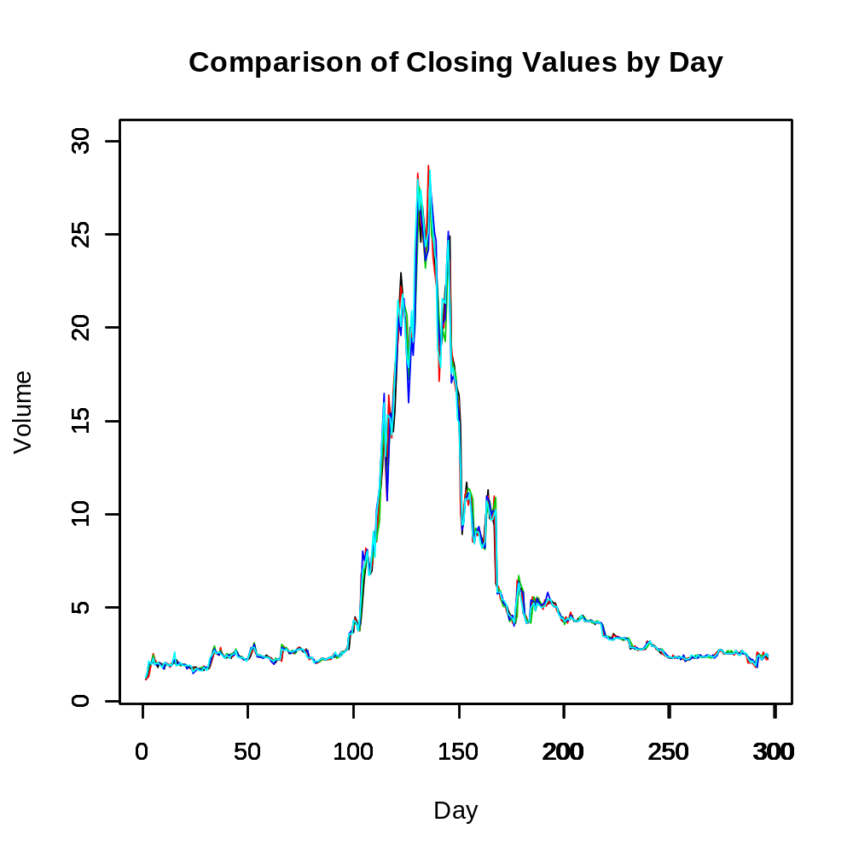
2. The file “WeeklyFord.csv” and “MonthlyFord.csv” represent the weekly and monthly stock information of Ford Motor Company from January 1996 to present. Assuming the stock information for both datasets follow the normal distribution.
<a> Get the 95% confidence interval for Open, High, Low, and Close on both datasets.

normCI<-function(x1,c){
sdx1<-sd(x1)
n1<-length(x1)
x1bar<-mean(x1)
c<-(1-c)/2+c #this transforms the test from a one tailed test into a two tailed test
q<-qnorm(c,0,1)
lci<-x1bar-(q*sdx1)
uci<-x1bar+(q*sdx1)
print(lci)
print(uci)
}
normCI(weekly.ford$Open,.95)
-5.536029
12.80719

normCI(weekly.ford$Close,.95)
-5.437314
12.63157

normCI(weekly.ford$High,.95)
-5.999899
13.90052

normCI(weekly.ford$Low,.95)
-5.01651
11.61234

normCI(monthly.ford$Open,.95)
-5.653954
12.92131

normCI(monthly.ford$Close,.95)
-5.553715
12.7092

normCI(monthly.ford$High,.95)
-6.63875
15.30507

normCI(monthly.ford$Low,.95)
-4.422271
10.37982

<b> Plot the confidence interval you get above on top of the Open, High, Low, and Close on both datasets.
weekly.ford<-read.csv("F:/Documents/WeeklyFord.csv",dec=".",sep=",",header=T)
attach(weekly.ford)
wfg<-ts(weekly.ford$Open,start=1,freq=1)
weeklyopenuci<-seq(from=12.80719,to=12.80719,length=length(weekly.ford$Open))
weeklyopenlci<-seq(from=0,to=0,length=length(weekly.ford$Open))
wlolci<-ts(weeklyopenlci,start=1,freq=1)
wlouci<-ts(weeklyopenuci,start=1,freq=1)
plot(wfg,main="Weekly Ford Opening Price",xlab="Day",ylab="Volume",ylim=c(1,30),col=1)
par(new=T)
plot(wlolci,main="",xlab="",ylab="",ylim=c(1,30),col=2)
par(new=T)
plot(wlouci,main="",xlab="",ylab="",ylim=c(1,30),col=3)
legend(300,25,c("Data","Lower Confidence Interval","Upper Confidence Interval),fill=1:3,cex=.8)

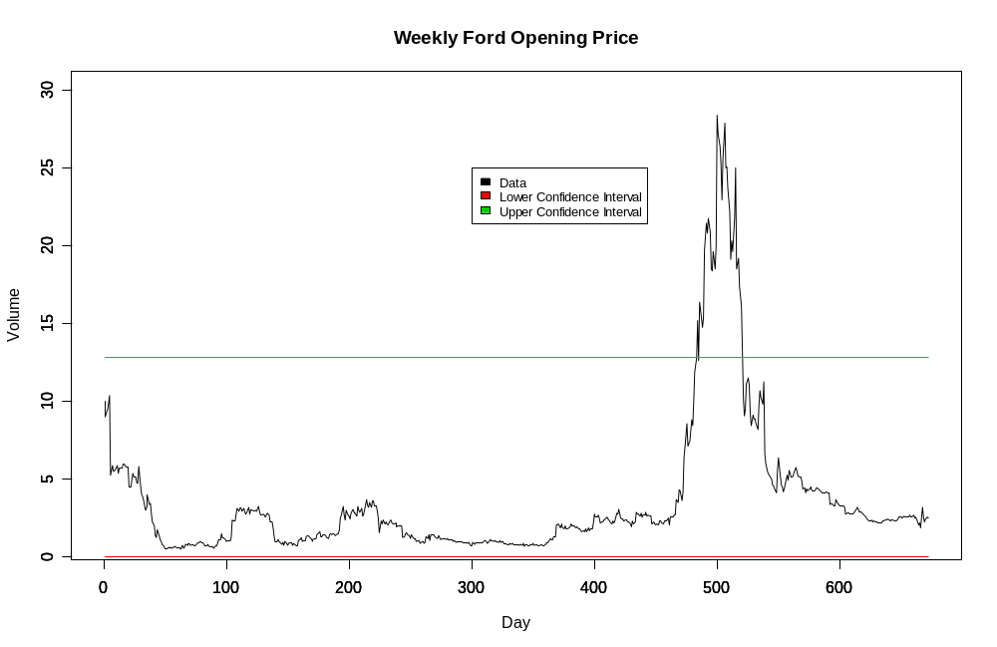
weekly.ford<-read.csv("F:/Documents/WeeklyFord.csv",dec=".",sep=",",header=T)
attach(weekly.ford)
wfg<-ts(weekly.ford$Close,start=1,freq=1)
weeklycloseuci<-seq(from=12.63157,to=12.63157,length=length(weekly.ford$Close))
weeklycloselci<-seq(from=0,to=0,length=length(weekly.ford$Close))
wlolci<-ts(weeklycloselci,start=1,freq=1)
wlouci<-ts(weeklycloseuci,start=1,freq=1)
plot(wfg,main="Weekly Ford Closing Price",xlab="Day",ylab="Volume",ylim=c(1,30),col=1)
par(new=T)
plot(wlolci,main="",xlab="",ylab="",ylim=c(1,30),col=2)
par(new=T)
plot(wlouci,main="",xlab="",ylab="",ylim=c(1,30),col=3)
legend(100,25,c("Data","Lower Confidence Interval","Upper Confidence Interval"),fill=1:3,cex=.8)
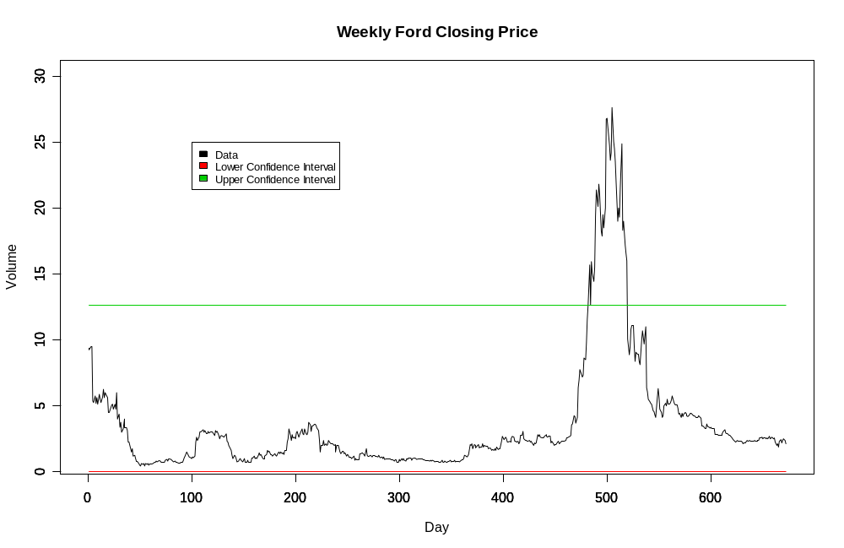
monthly.ford<-read.csv("F:/Documents/MonthlyFord.csv",dec=".",sep=",",header=T)
attach(monthly.ford)
mfg<-ts(monthly.ford$Close,start=1,freq=1)
monthlycloseuci<-seq(from=12.7092,to=12.7092,length=length(monthly.ford$Close))
monthlycloselci<-seq(from=0,to=0,length=length(monthly.ford$Close))
mlolci<-ts(monthlycloselci,start=1,freq=1)
mlouci<-ts(monthlycloseuci,start=1,freq=1)
plot(mfg,main="Monthly Ford Closing Price",xlab="Day",ylab="Volume",ylim=c(1,30),col=1)
par(new=T)
plot(mlolci,main="",xlab="",ylab="",ylim=c(1,30),col=2)
par(new=T)
plot(mlouci,main="",xlab="",ylab="",ylim=c(1,30),col=3)
legend(50,25,c("Data","Lower Confidence Interval","Upper Confidence Interval"),fill=1:3,cex=.8)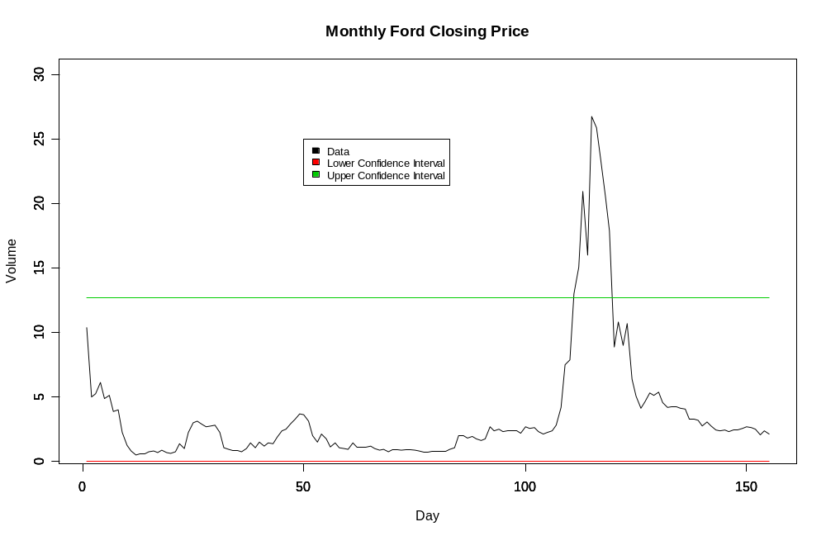
monthly.ford<-read.csv("F:/Documents/MonthlyFord.csv",dec=".",sep=",",header=T)
attach(monthly.ford)
mfg<-ts(monthly.ford$Open,start=1,freq=1)
monthlyopenuci<-seq(from= 12.92131,to= 12.92131,length=length(monthly.ford$Open))
monthlyopenlci<-seq(from=0,to=0,length=length(monthly.ford$Close))
mlolci<-ts(monthlyopenlci,start=1,freq=1)
mlouci<-ts(monthlyopenuci,start=1,freq=1)
plot(mfg,main="Monthly Ford Opening Price",xlab="Day",ylab="Volume",ylim=c(1,30),col=1)
par(new=T)
plot(mlolci,main="",xlab="",ylab="",ylim=c(1,30),col=2)
par(new=T)
plot(mlouci,main="",xlab="",ylab="",ylim=c(1,30),col=3)
legend(50,25,c("Data","Lower Confidence Interval","Upper Confidence Interval"),fill=1:3,cex=.8)
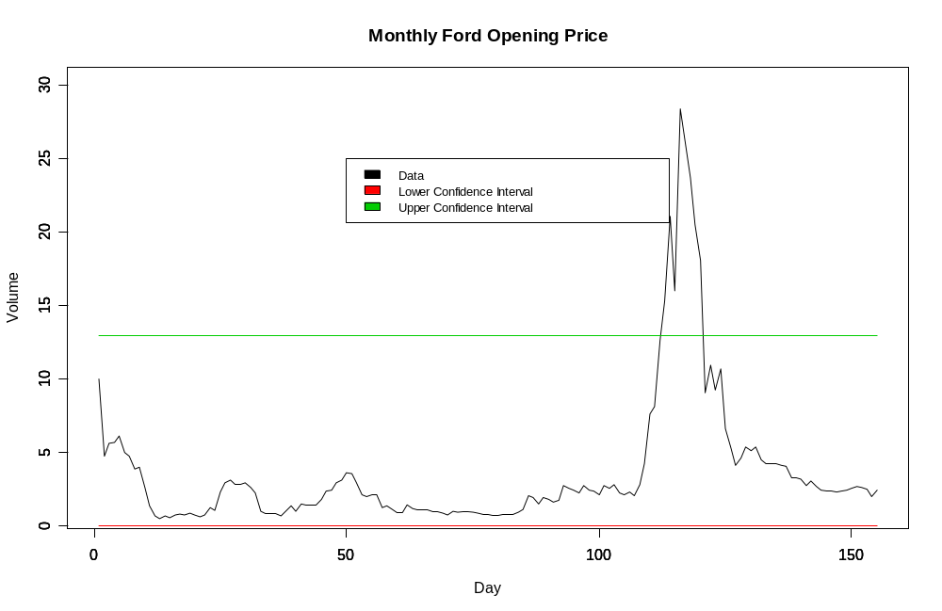
monthly.ford<-read.csv("F:/Documents/MonthlyFord.csv",dec=".",sep=",",header=T)
attach(monthly.ford)
mfg<-ts(monthly.ford$High,start=1,freq=1)
monthlyhighuci<-seq(from= 15.30507,to= 15.30507,length=length(monthly.ford$High))
monthlyhighlci<-seq(from=0,to=0,length=length(monthly.ford$High))
mlolci<-ts(monthlyhighlci,start=1,freq=1)
mlouci<-ts(monthlyhighuci,start=1,freq=1)
plot(mfg,main="Monthly Ford High Price",xlab="Day",ylab="Volume",ylim=c(1,30),col=1)
par(new=T)
plot(mlolci,main="",xlab="",ylab="",ylim=c(1,30),col=2)
par(new=T)
plot(mlouci,main="",xlab="",ylab="",ylim=c(1,30),col=3)
legend(10,25,c("Data","Lower Confidence Interval","Upper Confidence Interval"),fill=1:3,cex=.8)
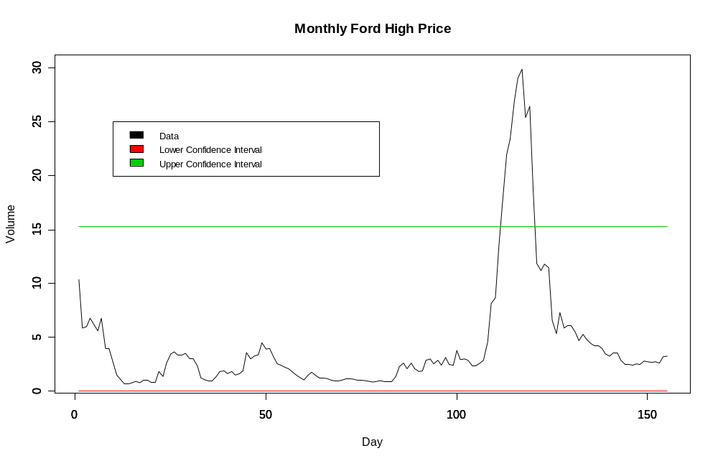
monthly.ford<-read.csv("F:/Documents/MonthlyFord.csv",dec=".",sep=",",header=T)
attach(monthly.ford)
mfg<-ts(monthly.ford$Low,start=1,freq=1)
monthlylowuci<-seq(from= 10.37982,to= 10.37982,length=length(monthly.ford$Low))
monthlylowlci<-seq(from=0,to=0,length=length(monthly.ford$Low))
mlolci<-ts(monthlylowlci,start=1,freq=1)
mlouci<-ts(monthlylowuci,start=1,freq=1)
plot(mfg,main="Monthly Ford Low Price",xlab="Day",ylab="Volume",ylim=c(1,30),col=1)
par(new=T)
plot(mlolci,main="",xlab="",ylab="",ylim=c(1,30),col=2)
par(new=T)
plot(mlouci,main="",xlab="",ylab="",ylim=c(1,30),col=3)
legend(10,25,c("Data","Lower Confidence Interval","Upper Confidence Interval"),fill=1:3,cex=.8)
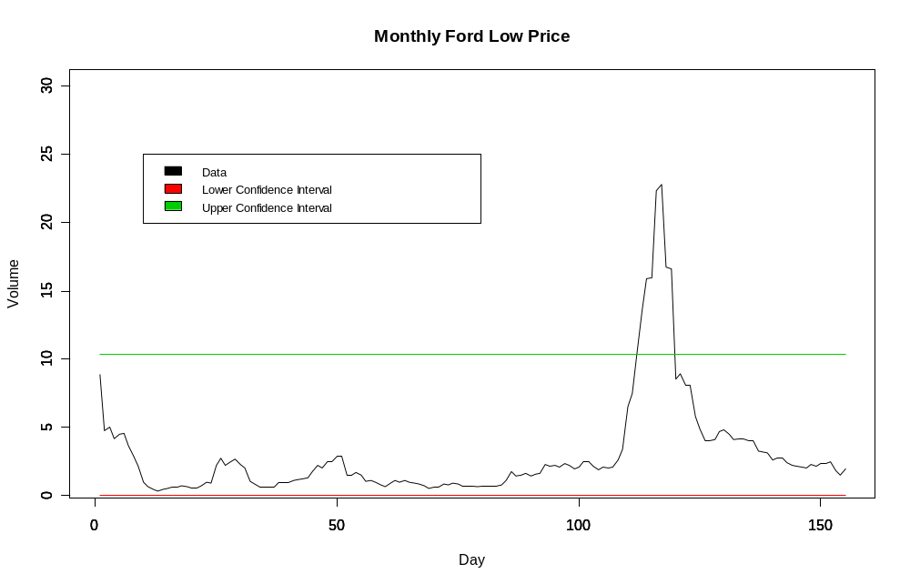
weekly.ford<-read.csv("F:/Documents/WeeklyFord.csv",dec=".",sep=",",header=T)
attach(weekly.ford)
wfg<-ts(weekly.ford$Low,start=1,freq=1)
weeklylowuci<-seq(from= 10.37982,to= 10.37982,length=length(weekly.ford$Low))
weeklylowlci<-seq(from=0,to=0,length=length(weekly.ford$Low))
wlolci<-ts(weeklylowlci,start=1,freq=1)
wlouci<-ts(weeklylowuci,start=1,freq=1)
plot(wfg,main="Weekly Ford Low Price",xlab="Day",ylab="Volume",ylim=c(1,30),col=1)
par(new=T)
plot(wlolci,main="",xlab="",ylab="",ylim=c(1,30),col=2)
par(new=T)
plot(wlouci,main="",xlab="",ylab="",ylim=c(1,30),col=3)
legend(10,25,c("Data","Lower Confidence Interval","Upper Confidence Interval"),fill=1:3,cex=.8)
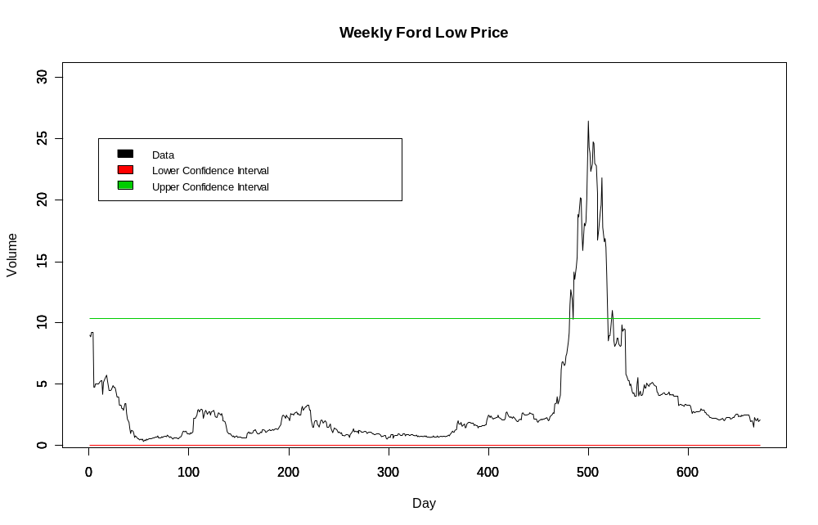

weekly.ford<-read.csv("F:/Documents/WeeklyFord.csv",dec=".",sep=",",header=T)
attach(weekly.ford)
wfg<-ts(weekly.ford$High,start=1,freq=1)
weeklyhighuci<-seq(from= 15.30507,to= 15.30507,length=length(weekly.ford$High))
weeklyhighlci<-seq(from=0,to=0,length=length(weekly.ford$High))
wlolci<-ts(weeklyhighlci,start=1,freq=1)
wlouci<-ts(weeklyhighuci,start=1,freq=1)
plot(wfg,main="Weekly Ford High Price",xlab="Day",ylab="Volume",ylim=c(1,30),col=1)
par(new=T)
plot(wlolci,main="",xlab="",ylab="",ylim=c(1,30),col=2)
par(new=T)
plot(wlouci,main="",xlab="",ylab="",ylim=c(1,30),col=3)
legend(10,25,c("Data","Lower Confidence Interval","Upper Confidence Interval"),fill=1:3,cex=.8)
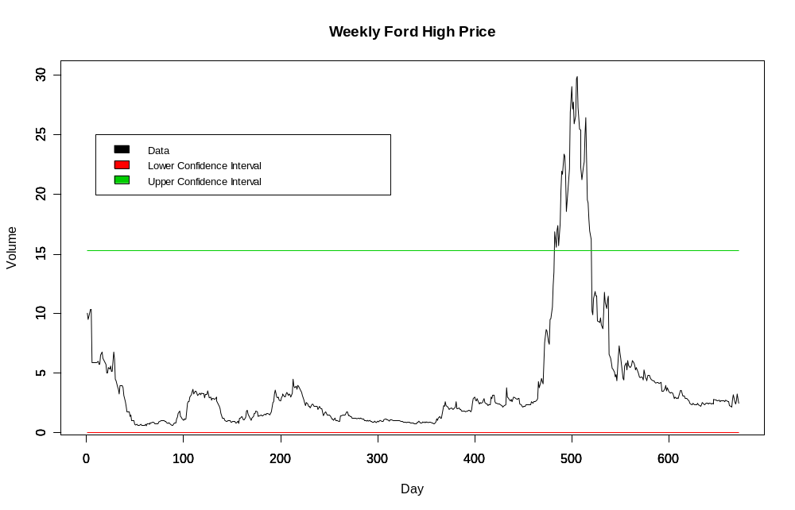
<c> Create the annual average vectors for the Open, High, Low, and Close on both datasets.
weekly.ford<-read.csv("G:/Documents/WeeklyFord.csv",dec=".",sep=",",header=T)
monthly.ford<-read.csv("G:/Documents/MonthlyFord.csv",dec=".",sep=",",header=T)
attach(weekly.ford)
attach(monthly.ford)
anhiw<-c(mean(weekly.ford$High[1:54]),
mean(weekly.ford$High[55:106]),
mean(weekly.ford$High[107:158]),
mean(weekly.ford$High[159:209]),
mean(weekly.ford$High[210:261]),
mean(weekly.ford$High[262:313]),
mean(weekly.ford$High[314:365]),
mean(weekly.ford$High[366:417]),
mean(weekly.ford$High[418:469]),
mean(weekly.ford$High[470:522]),
mean(weekly.ford$High[523:573]),
mean(weekly.ford$High[574:626]),
mean(weekly.ford$High[627:672]))
anualhigh<-ts(anhiw,start=1,freq=1)
plot(anualhigh,main="",xlab="Day",ylab="Volume",ylim=c(1,30),col=1)

anopw<-c(mean(Open[1:54]),
mean(weekly.ford$Open[55:106]),
mean(weekly.ford$Open[107:158]),
mean(weekly.ford$Open[159:209]),
mean(weekly.ford$Open[210:261]),
mean(weekly.ford$Open[262:313]),
mean(weekly.ford$Open[314:365]),
mean(weekly.ford$Open[366:417]),
mean(weekly.ford$Open[418:469]),
mean(weekly.ford$Open[470:522]),
mean(weekly.ford$Open[523:573]),
mean(weekly.ford$Open[574:626]),
mean(weekly.ford$Open[627:672]))
anualopen<-ts(anopw,start=1,freq=1)

anloww<-c(mean(Open[1:54]),
mean(weekly.ford$Low[55:106]),
mean(weekly.ford$Low[107:158]),
mean(weekly.ford$Low[159:209]),
mean(weekly.ford$Low[210:261]),
mean(weekly.ford$Low[262:313]),
mean(weekly.ford$Low[314:365]),
mean(weekly.ford$Low[366:417]),
mean(weekly.ford$Low[418:469]),
mean(weekly.ford$Low[470:522]),
mean(weekly.ford$Low[523:573]),
mean(weekly.ford$Low[574:626]),
mean(weekly.ford$Low[627:672]))
anuallowm<-ts(anloww,start=1,freq=1)

anclw<-c(mean(Close[1:54]),
mean(weekly.ford$Close[55:106]),
mean(weekly.ford$Close[107:158]),
mean(weekly.ford$Close[159:209]),
mean(weekly.ford$Close[210:261]),
mean(weekly.ford$Close[262:313]),
mean(weekly.ford$Close[314:365]),
mean(weekly.ford$Close[366:417]),
mean(weekly.ford$Close[418:469]),
mean(weekly.ford$Close[470:522]),
mean(weekly.ford$Close[523:573]),
mean(weekly.ford$Close[574:626]),
mean(weekly.ford$Close[627:672]))
anualclose<-ts(anclw,start=1,freq=1)

anhim<-c(mean(High[1:12]),
mean(monthly.ford$High[13:24]),
mean(monthly.ford$High[25:36]),
mean(monthly.ford$High[37:48]),
mean(monthly.ford$High[49:60]),
mean(monthly.ford$High[61:72]),
mean(monthly.ford$High[73:84]),
mean(monthly.ford$High[85:96]),
mean(monthly.ford$High[97:108]),
mean(monthly.ford$High[109:120]),
mean(monthly.ford$High[121:132]),
mean(monthly.ford$High[133:144]),
mean(monthly.ford$High[145:155]))
anualclosem<-ts(anhim,start=1,freq=1)

anopm<-c(mean(Open[1:12]),
mean(monthly.ford$Open[13:24]),
mean(monthly.ford$Open[25:36]),
mean(monthly.ford$Open[37:48]),
mean(monthly.ford$Open[49:60]),
mean(monthly.ford$Open[61:72]),
mean(monthly.ford$Open[73:84]),
mean(monthly.ford$Open[85:96]),
mean(monthly.ford$Open[97:108]),
mean(monthly.ford$Open[109:120]),
mean(monthly.ford$Open[121:132]),
mean(monthly.ford$Open[133:144]),
mean(monthly.ford$Open[145:155]))
anualopenm<-ts(anopm,start=1,freq=1)

anclm<-c(mean(Close[1:12]),
mean(monthly.ford$Close[13:24]),
mean(monthly.ford$Close[25:36]),
mean(monthly.ford$Close[37:48]),
mean(monthly.ford$Close[49:60]),
mean(monthly.ford$Close[61:72]),
mean(monthly.ford$Close[73:84]),
mean(monthly.ford$Close[85:96]),
mean(monthly.ford$Close[97:108]),
mean(monthly.ford$Close[109:120]),
mean(monthly.ford$Close[121:132]),
mean(monthly.ford$Close[133:144]),
mean(monthly.ford$Close[145:155]))
anualclosem<-ts(anclm,start=1,freq=1)

<d> Graph the comparison for the Open, High, Low, and Close on both annual averages.

plot(anualhigh,main="Comparison of Anual Averages",xlab="Time Series",ylab="Volume",ylim=c(1,30),col=1)
par(new=T)
plot(anualhighm,main="",xlab="",ylab="",ylim=c(1,30),col=2)
par(new=T)
legend(4,25,c("Weekly Average","Monthly Average"),fill=1:2,cex=.8)

plot(anualopen,main="Comparison of Anual Averages",xlab="Time Series",ylab="Volume",ylim=c(1,30),col=3)
par(new=T)
plot(anualopenm,main="",xlab="",ylab="",ylim=c(1,30),col=4)
par(new=T)
legend(4,25,c("Weekly Average","Monthly Average"),fill=3:4,cex=.8)

plot(anuallow,main="Comparison of Anual Averages",xlab="Time Series",ylab="Volume",ylim=c(1,30),col=5)
par(new=T)
plot(anuallowm,main="",xlab="",ylab="",ylim=c(1,30),col=6)
par(new=T)
legend(4,25,c("Weekly Average","Monthly Average"),fill=5:6,cex=.8)

plot(anualclose,main="Comparison of Anual Averages",xlab="Time Series",ylab="Volume",ylim=c(1,30),col=7)
par(new=T)
plot(anualclosem,main="",xlab="",ylab="",ylim=c(1,30),col=8)
par(new=T)
legend(4,25,c("Weekly Average","Monthly Average"),fill=7:8,cex=.8)

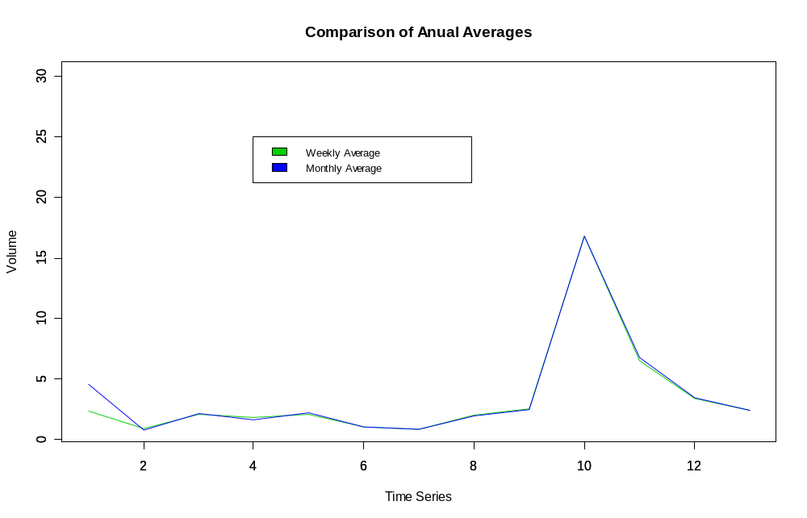
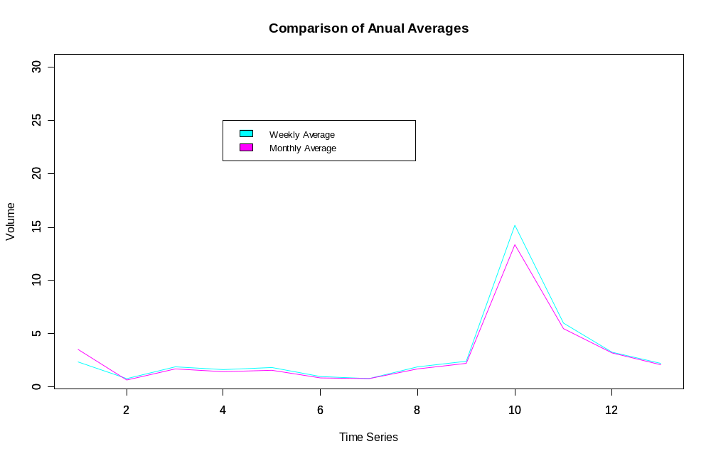
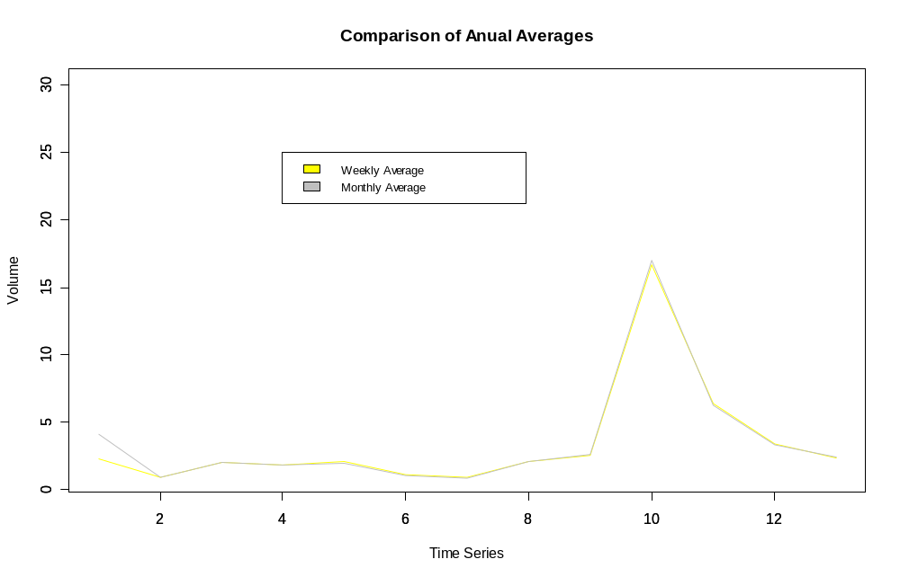
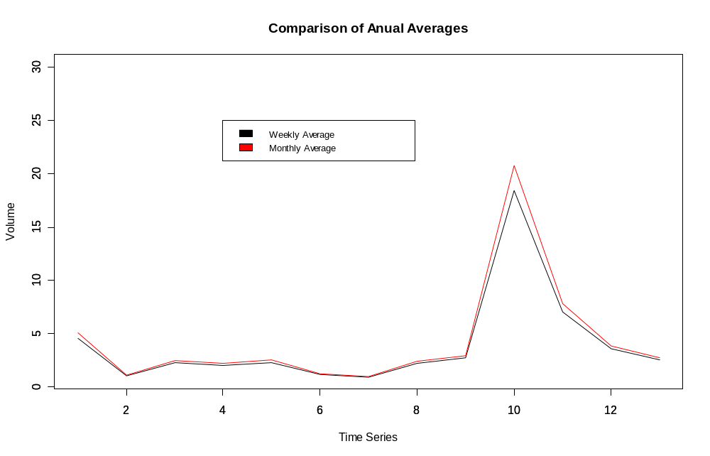
3. The file “Sal.txt” represents the salary information of the professors of the University of South Florida.
<a>Read the data in, removing the columns to ignore. Save this data in a data frame.
asalary<-read.table("F:/salary.txt",header=T,sep=",",dec=".")
nsalary<-data.frame(subset(asalary,select=c(Lname,Fname,MI,DisciPline,ProfessorialRank,WeeksinYear,SalaryLastYear,SalaryThisYear)))
attach(asalary)
<b> Count the number of professors whose salary is above 100,000.
scount<-0
for(i in 1:length(SalaryThisYear)){
if(SalaryThisYear[i]>100000){
scount<-scount+1
}
}
<c> Count the number of professors whose salary is below 40,000.
u40count<-0
for(i in 1:length(SalaryThisYear)){
if(SalaryThisYear[i]<40000){
u40count<-u40count+1
}
}
<d> Get the 90% confidence interval for those professors whose Rank “9001”.
normCI<-function(x1,c){
sdx1<-sd(x1)
n1<-length(x1)
x1bar<-mean(x1)
c<-(1-c)/2+c #this transforms the test from a one tailed test into a two tailed test
q<-qnorm(c,0,1)
lci<-x1bar-(q*sdx1)
uci<-x1bar+(q*sdx1)
print(lci)
print(uci)
}
counter<-0
salary9001<-seq(0,0,length=length(counter))

for(i in 1:1686){
if(ProfessorialRank[i]==9001){
counter<-counter+1
salary9001[counter]<-SalaryThisYear[i]
}
}
normCI(salary9001,.9)
<e> Calculate the average salary increase for all USF professors.
average.raise<-abs(mean(SalaryLastYear)-mean(SalaryThisYear))
[1] 9053.087

<f> Generate a bar graph of this year's average salary by ProfessorialRank 9001=Professor, 9002=Associate Prof, 9003=Asst Prof, 9004=Instructor, 9005=Lecturer....etc).

